Article Selected for Review:
Xiao, W. N., Nunn, G. M., Fufeng, A. B., Belu, N., Brookman, R. K., Halim, A., Krysmanski, E. C., & Cameron, R. K. (2024). Exploring Pseudomonas syringae pv. Tomato biofilm-like aggregate formation in susceptible and PTI-responding Arabidopsis thaliana. Molecular Plant Pathology, 25(1), e13403. https://doi.org/10.1111/mpp.13403

Article Passage for Review #1:
“Alginate is an important component of the extracellular matrix of P. aeruginosa biofilms (Rasamiravaka et al., 2015), and Pst encodes alginate biosynthesis genes (Buell et al., 2003); therefore, the contribution of alginate to bacterial aggregate formation was investigated. Arabidopsis leaves were inoculated with virulent Pst-GFP or Pst-GFP ΔalgD, an alginate biosynthesis mutant (Markel et al., 2016). The effect of plant-produced SA on wild-type Pst and Pst ΔalgD was also investigated by comparing the multiplication and aggregate formation (numbers and size) of GFP-expressing virulent Pst and Pst ΔalgD in Col-0 and SA-deficient sid2-2 plants. Both Col-0 and sid2-2 plants inoculated with wild-type Pst and Pst ΔalgD supported similar levels of bacterial multiplication (Figure S2a). In addition, Pst and Pst ΔalgD grew similarly well over 72 h when cultured in hrp-inducing medium that mimics the leaf intercellular environment (Figure S3a). These data suggest that the ability to produce alginate is not important for Pst multiplication in Arabidopsis.” (Xiao et al., 2024)

Issues with their presentation of the results:
The authors state that the growth of the wild-type bacteria and the mutant is similar both in planta and in vitro in the hrp-inducing minimal media (HIM). What is problematic about this is that a large p-value cannot be used to conclude that two means are similar, and the authors do not indicate a cut-off for what is considered different, nor do they report confidence intervals for the data. In my experience with bacterial data in our lab, a significant reduction in bacterial level is at least a 2-fold difference, which would be considered a small effect, a 10 to 20-fold difference to be considered a moderate effect, and a >20-fold difference would be considered a large effect. The variation in the data presented is also quite large (error bars represent standard deviation), and with repeat experiments or a larger sample size, a statistically clear difference between Pst and Pst ΔalgD level at 72h in Col-0 might be observed. Because of the aforementioned reasons, it would be more appropriate for the authors to state that the differences between the growth of Pst and Pst ΔalgD were statistically unclear.

The Rewritten Passage:
“… Differences in bacterial level in Col-0 and sid2-2 plants inoculated with wild-type Pst and Pst ΔalgD were statistically unclear. In addition, we failed to observe a statistically clear difference in the growth of Pst and Pst ΔalgD in hrp-inducing minimal media, which mimics the leaf intercellular environment, over a 72h period. We infer from these data that the ability to produce alginate does not have a biologically significant effect on Pst multiplication in Col-0 Arabidopsis.”

Fixing Associated Figure Captions:
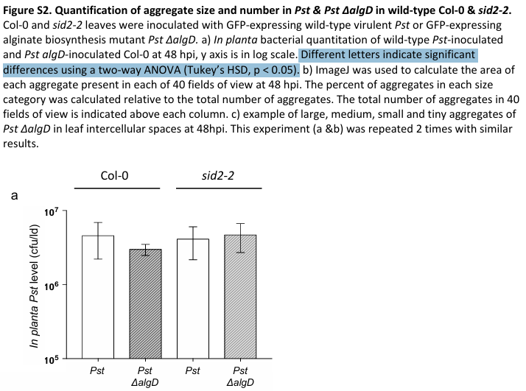
…Different letters indicate statistically clear differences determined using a two-way ANOVA and post-hoc Tukey’s HSD test (α = 0.05). …

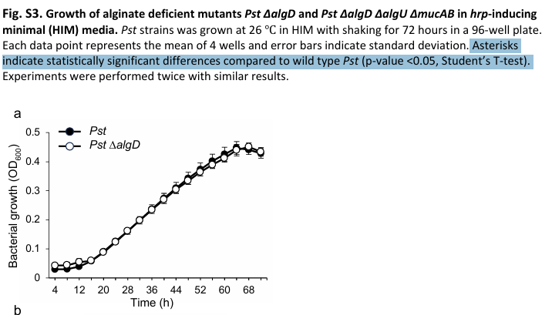
… Asterisks indicate statistically clear differences as determined by Student’s T-test, in the growth of Pst ΔalgD compared to wild-type Pst in Col-0 or sid2-2 plants (α = 0.05, Student's two-tailed t-test)...

Article Passage for Review #2:
“Both the triple and quadruple mutants multiplied to similar levels, approximately 10-fold less than wild-type Pst (Figure 4a). This was surprising given that Pst ΔalgD ΔalgU ΔmucAB formed very few aggregates (8), while Pst ΔalgU ΔmucAB formed about three times more (29) and Pst formed 49 very large aggregates (56 in total) (Figure 4b). These data suggest that AlgU contributes to aggregate formation and in the absence of AlgU and AlgD, Pst formed very few aggregates. However, in response to all three Pst strains, Col-0 leaves produced similarly low levels (c.120 to 350 ng/mL IWF) of intercellular SA compared to SA levels observed during the ARR response (1000–2000 ng/mL IWF) (Wilson et al., 2017), suggesting that like wild-type Pst, both Pst ΔalgU ΔmucAB and Pst ΔalgD ΔalgU ΔmucAB suppress SA-mediated plant defence”

Issues with the Author’s Presentation:
Here, the authors again make the mistake of claiming two bacterial populations grew to similar levels in planta based on the results of one-way ANOVA and post-hoc tukey’s HSD. The test only demonstrates if a difference between the two means is statistically clear. The inability of the quadruple mutant to produce alginate probably does affect growth in planta relative to the triple mutant, but the effect may be small.
Later in the paragraph, the description/presentation of the data was not what the data showed, nor what the test statistic indicated about the data. The authors describe Col-0 as generating “similarly low levels of SA” in response to all three strains of bacteria. The issue here is that the test statistic (ANOVA and post-hoc Tukey’s HSD) only demonstrates if there are statistically clear differences between the means (ANOVA), and between which means a statistically clear difference is observed (Tukey’s HSD). They do not demonstrate similarity between means where there was insufficient evidence to reject the null hypothesis. Additionally, statistically clear differences are not described in the passage. In the data presented, there is a statistically clear difference in the SA levels in untreated or mock-treated plants, relative to plants inoculated with the triple or quadruple mutant. Furthermore, there was a statistically clear difference in SA generated in response to wild-type Pst and the triple mutant.
Here, providing expected thresholds for suppressed SA-mediated resistance (100-500 ng/mL IWF) and unsuppressed SA-mediated resistance (1000-2000 ng/mL IWF) would allow for a clearer inference of biological significance, and rely on statistical tests to only demonstrate how clear differences are.

Associated figure captions:
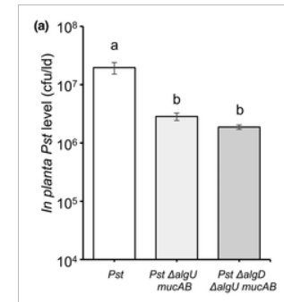
Original Caption:
(a) In planta bacterial quantification in Col-0 at 48 h post-inoculation (hpi). The y axis is cfu/leaf disc (ld) in log scale. Different letters indicate significant differences as determined using one-way analysis of variance followed by Tukey's honestly significant difference test (p < 0.05).
Revised Caption:
(a) In planta bacterial quantification in Col-0 at 48 h post-inoculation (hpi). The y axis is cfu/leaf disc (ld) in log scale. Different letters indicate statistically clear differences as determined using one-way analysis of variance followed by Tukey's HSD test (α = 0.05).
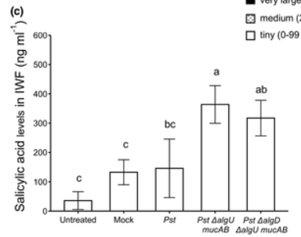
Original Caption:
(c) Salicylic acid (SA) accumulation was determined in intercellular washing fluids (IWF) collected at 24 hpi with Pst strains. Different letters indicate significant differences as determined using one-way analysis of variance followed by Tukey's honestly significant difference test (p < 0.05).
Revised Caption:
(c) Salicylic acid (SA) accumulation was determined in intercellular washing fluids (IWF) collected at 24 hpi with Pst strains. Different letters indicate statistically clear differences as determined using one-way analysis of variance followed by Tukey's honestly significant difference test (α = 0.05).

Revised Passage #2:
Both the triple and quadruple mutants multiplied to approximately 10-fold lower levels than wild-type Pst, and an effect of the ΔalgD mutation on growth of the quadruple mutant relative to the triple mutant was statistically unclear.….
…However, in response to all three strains, Col-0 produced lower levels of intercellular SA than is observed in the IWFs of ARR-responding plants (1000-2000 ng/mL IWF; Wilson et al., 2017). Although it was statistically clear Col-0 plants generated slightly higher levels of intercellular SA in response to the triple mutant relative to wild-type Pst, the difference was small (~250 ng/mL IWF) and still characteristic of suppressed SA-mediated defenses (<550 ng/mL IWF vs. 1000-2000 ng/mL IWF). These results suggest that, like wild-type Pst, both the triple and quadruple mutants suppress SA-mediated plant defenses.

Passage for Review #3:
Pst biofilm-like aggregate formation was also examined in mock- and flg22-treated leaves of fls2 plants (a flg22 receptor mutant that cannot mount flg22-induced PTI) and of sid2-2 plants (which cannot accumulate SA) (Figure 5). A significant 1.5-fold reduction in bacterial levels in flg22-treated compared to mock-treated sid2-2 was observed, indicating that a modest PTI response occurred in sid2-2 (Figure 5a), as expected as PTI is primarily SA-dependent with some SA-independent components (Mine et al., 2018). In terms of aggregate formation (Figure 5b), five aggregates (four tiny, one very large) were observed in PTI-responding (flg22-treated) Col-0 plants compared to susceptible (mock-treated) Col-0 or sid2-2 leaves, both with 25 aggregates (21 and 22 very large, respectively). In fls2 plants, which cannot initiate PTI in response to flg22 treatment, aggregate numbers were similar in both mock- (39) and flg22-treated leaves (37).

Issues with the Author's Presentation:
In this passage, there is a good example of where the meaning of significance gets muddied by the conflation of biological significance with statistical significance. Here, a significant 1.5-fold reduction may refer to a statistically clear difference or biological significance. I believe that the authors intended this as a biologically significant inference based on later sentences, but it is not clear because of other uses of the word throughout the article. The last sentence in this passage is more problematic, as the authors claim the aggregate numbers were similar in the mock- and PTI-responding plants. The only statistical test used on this data was a Kruskal-Wallis test, which assessed the distribution of aggregate sizes and not total aggregate numbers. Therefore, this sentence is claiming similarity based on data from a single experiment. Although this experiment was repeated seven additional times with similar results, they should have compiled the data from those experiments to test if the total aggregate number differed between treatment groups. Then, using confidence intervals, they could infer that the total aggregate number was similar between mock- and PTI-induced fls2 plants.

Associated Figures
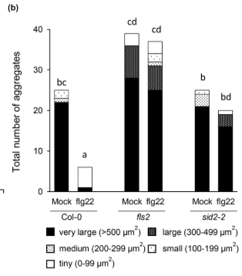
Original Caption:
(b) Aggregate formation was monitored by categorizing each microscopic field of view (40 fields of view per treatment) as with or without aggregates in mock-treated and flg22-treated Col-0, fls2, and sid2-2 at 48 hpi. Different letters indicate significant differences in aggregate size distribution among groups as determined using the Kruskal–Wallis test (p < 0.05).

Revised Caption:
(b) Aggregate formation was monitored by categorizing each microscopic field of view (40 fields of view per treatment) as with or without aggregates in mock-treated and flg22-treated Col-0, fls2, and sid2-2 at 48 hpi. Different letters indicate statistically clear differences in aggregate size distribution among groups as determined using the Kruskal–Wallis test (α = 0.05).

Revised Passage:
Pst biofilm-like aggregate formation was also examined in mock- and flg22-treated leaves of fls2 plants (a flg22 receptor mutant that cannot mount flg22-induced PTI) and of sid2-2 plants (which cannot accumulate SA) (Figure 5). A small but statistically clear difference in Pst level was observed in the leaves of mock- and flg22-induced sid2-2 mutants, indicating a modest PTI response occurred in sid2-2 (Figure 5a), as expected as PTI is primarily SA-dependent with some SA-independent components (Mine et al., 2018). In terms of aggregate formation (Figure 5b), five aggregates (four tiny, one very large) were observed in PTI-responding (flg22-treated) Col-0 plants compared to susceptible (mock-treated) Col-0 or sid2-2 leaves, both with 25 aggregates (21 and 22 very large, respectively). In fls2 plants, which cannot initiate PTI in response to flg22 treatment, differences in aggregate size distribution were statistically unclear.

